# A Minor Project Final Report on

Ecare -Your Ultimate Destination for Healthcare Solutions.

Submitted in Partial Fulfillment of the Requirements for

The Degree of **BACHELOR OF ENGINEERING IN INFORMATION TECHNOLOGY**

Under Pokhara University

**Submitted by:**

Prabin Yadav, 201551

Pradeep Chaudhary,201525 Rahul Kumar Yadav, 201530

## Under the supervision of Mr. Roshan Kumar Sah

Date: 30th Jul 2024



C

2001

**Department of Information Technology**

**NEPAL COLLEGE OF**

**INFORMATIONTECHNOLOGY**

Balkumari, Lalitpur, Nepal

## ACKNOWLWDGEMENT

We would like to express our sincere thanks to Nepal College of Information Technology for providing us such an opportunity to perform a minor project for the partial fulfillment of the requirement for the degree of B.E in IT Engineering.

It’s our privilege to express our sense of gratitude to our respected supervisor Dr. ROSHAN CHITRAKAR for his unparalleled knowledge and moral fiber and judgment along with his know-how-based method was an immense support for the completion of our project.

Lastly, we would like to thank our parents and beloved friends who helped and motivated us for the successful completion of the project.

Pradeep Chaudhary (201525)

Prabin Yadav (201551)

Rahul Kumar Yadav (201530)

i

## ABSTRACT

Our project “Ecare” is a Hospital Management System project is a web based application which encompasses patient registration, storing patient details, and scheduling appointments with doctors. The software assigns a unique ID to each patient and automatically stores the details of every patient and doctors. Users can search for a doctor's availability and retrieve patient details using the unique ID. Access to the system is secured with a username and password, available to administrators and receptionists, who are the only ones authorized to add data to the database. The data can be easily retrieved, and the interface is designed to be user-friendly. The system ensures data protection for personal use and enhances the speed of data processing. The system primarily consists of two modules: the Administration module and the User module, which includes patients and doctors. The application maintains strict authentication protocols to ensure secure access. The Administrator's responsibilities include managing doctor and patient information. To support this, separate databases were designed for patients and doctors, accessible by the administrator. Complaints submitted by users are addressed by the authorities.

The Patient module allows users to check appointments and prescriptions. Additionally, users can pay doctor's fees online.

***Keywords****: Html, CSS, Php, MySQL, Bootstrap*

ii

# Table of Contents

1. INTRODUCTION 1
   1. Problem Statement 1
   2. Objectives 2
   3. Scope 2
   4. Purpose 3
   5. Overview 4
2. LITERATURE REVIEW 5
3. METHODOLOGY 6
   1. SOFTWARE DEVELOPMENT LIFECYCLE 7
      1. REQUIREMENT ANALYSIS 7
      2. DESIGN PHASE 7
      3. CODING PHASE 7
      4. TESTING PHASE 7
   2. SOFTWARE SPECIFICATION 7
4. PROPOSED SYSTEM 9
5. USE CASE DAIGRAM 10
6. ER-DIAGRAM 11
7. SEQUENCE DIAGRAM 12
8. CLASS DIAGRAM 13
9. PROJECT TASK & TIME SCHEDULE 14
10. APPENDIX… 15
11. REFERENCE 20

iii

**LIST OF FIGURES**

* Figure 1- Incremental model
* Figure 2 - Illustration of SDLC
* Figure 3 – USE CASE Diagram
* Figure 4 – Er Diagram
* Figure 5 – Sequence Diagram
* Figure 6 – Class Diagram
* Figure 7 – Home Interface
* Figure 8 – Login Page
* Figure 9 – Login Form
* Figure 10 – Reset Form
* Figure 11 – OTP Form
* Figure 12 – Payment gateway
* Figure 13 – Patient Panel
* Figure 14 – Doctor Panel
* Figure 15 – Admin Panel

iv

## INTRODUCTION

The "Ecare" Hospital Management System is an innovative software solution designed to streamline and enhance the operations of healthcare facilities. This comprehensive system manages the entire spectrum of hospital activities, ranging from patient registration and appointment scheduling to detailed record-keeping and billing. "Ecare" is engineered to provide a seamless and efficient experience for both healthcare providers and patients, ensuring high standards of data accuracy, security, and accessibility.

##### Problem Statement

In this busy world we don’t have the time to wait in infamously long hospital queues. The problem is, queuing at hospital is often managed manually by administrative staff, then take a token there and then wait for our turn then ask for the doctor and the most frustrating thing - we went there by traveling a long distance and then we come to know the doctor is on leave or the doctor can’t take appointments.

Healthcare facilities face numerous challenges in managing their operations efficiently. The traditional methods of handling patient registration, scheduling appointments, maintaining medical records, and processing payments are often cumbersome, time-consuming, and prone to errors. These inefficiencies can lead to delayed care, administrative burdens, and compromised patient satisfaction.

Some of the major problems are:-

* The reliance on paper records and manual data entry increases the risk of errors, data loss, and unauthorized access.
* Lack of a centralized system to manage appointments leads to scheduling conflicts, long waiting times, and underutilized resources.
* Patients and doctors often struggle with accessing up-to-date information, such as appointment schedules, prescriptions, and medical history.
* Traditional billing systems are inefficient, leading to delays in payment processing and difficulties in managing financial transactions.
* Lack of integrated communication tools between staff and patients results in miscommunication and coordination issues.

##### Objectives

To solve the drawbacks of the previous system stated in problem statement section 1.1, there is a need for a comprehensive, integrated Hospital Management System that can streamline operations, improve data accuracy, enhance security, and provide easy access to information for both healthcare providers and patients. The "Ecare" Hospital Management System aims to resolve these issues by offering a robust, user-friendly, and secure platform to manage all aspects of hospital administration efficiently.

Some major Objectives & benefits of implementing this system are:-

* To ensure accurate and up-to-date patient and doctor information is readily accessible to authorized personnel, facilitating better decision-making and patient care.
* To make online appointment between doctors and patients & check their appointment status.
* To pay the doctor’s consultant fee online to save their time.
* To make view on lab test, lab report & prescriptions online through panel.

##### Scope

The main scope deliverables of the project would be to:

* To facilitate online booking of appointments with doctors.
* To store and manage detailed information about doctors and patients.
* To allow administrators to update doctor schedules and specializations.
* To maintain digital records of patient visits, diagnoses, treatments, and prescriptions.
* To automate billing procedures for patient consultations, treatments, and services.

##### Purpose

* This software will help the company to be more efficient in registration of their patients and manage appointments, records of patients.
* It enables doctors and admin to view and modify appointments schedules if required.
* The purpose of this project is to computerize all details regarding patient details and hospital details.
* Provide a user-friendly interface and convenient features that enhance the patient experience.

#### GOALS

* To automate tasks like patient registration, scheduling appointments, and billing to save time and reduce mistakes.
* To give doctors quick access to patient records to provide better treatment.
* To allow patients to easily manage their appointments and view their medical information.
* To help doctors, staff, and patients communicate better with tools like appointment.
* To provide reports and data to help hospital managers make informed decisions.

##### Overview

Our application contains two modules – the admin module and the user module. Our application will not only help the admin to preview the monthly and/or yearly data but it will also allow them to edit, add or update records. The software will also help the admin to monitor the transactions made by the patients and generate confirmations for the same. The admin will be able to manage and update information about doctors.

The user module can be accessed by both the doctors and the patients. The doctor can confirm and/or cancel appointments. The doctors can even add prescriptions for their patients using our application. The patients will be able to apply for the appointment and make transaction for the same, and can even cancel appointments with the doctors. They can track details about the previous transactions made by them.

##### Advantages

* The system automates the manual procedure of managing hospital activities.
* Doctors can view their patients’ treatment records and details easily.
* It even generates an instant bill.
* The system is convenient and flexible to be used.
* It saves their time, efforts, money and resources.

##### Disadvantages

* Requires large database.
* The admin has to manually keep updating the information by entering the details in the system.
* Need Internet connection.

## LITERATURE REVIEW

The healthcare system in Nepal faces numerous challenges, including limited resources, inadequate infrastructure, and high patient loads. The implementation of effective Hospital Management Systems (HMS) is essential to improve the efficiency and quality of healthcare delivery. Traditionally, many hospitals in Nepal have relied on manual processes for patient registration, record-keeping, and appointment scheduling. Recently, there has been a gradual shift towards digital HMS, although the pace of adoption varies significantly across regions and types of hospitals, with private hospitals often being more advanced in this transition compared to public ones. Common features of these systems include patient registration, appointment scheduling, billing, and inventory management, while more advanced systems offer electronic medical records (EMR), lab integration, and reporting tools. Despite this, many systems face challenges in usability, especially among staff who are not tech-savvy.

The implementation of HMS in Nepal encounters several significant challenges. Technical infrastructure, such as reliable internet connectivity and modern computer systems, is often lacking, particularly in rural areas. Financial constraints are another major barrier, especially for public hospitals that struggle to allocate funds for new technology and its maintenance. Additionally, effective use of HMS requires adequate training for hospital staff, which many hospitals find difficult to provide due to time and resource limitations. Resistance from staff accustomed to manual processes also hinders the successful implementation of these systems, necessitating robust change management strategies. Moreover, systems often require customization to meet the specific needs of different hospitals, but the lack of local expertise in customizing and maintaining these systems presents a challenge. Scalability is another issue, as many existing HMS struggle to accommodate increasing patient data and advanced functionalities as hospitals grow.

Despite these challenges, there have been notable advancements and success stories. Some large hospitals in urban areas, such as Patan Hospital and Tribhuvan University Teaching Hospital, have successfully implemented comprehensive HMS, resulting in significant improvements in operational efficiency and patient care. The Nepalese government has recognized the importance of digital health and has been working towards policies that encourage the adoption of HMS. Initiatives launched by the Ministry of Health and Population aim to promote digital health solutions, supported by international aid and funding from organizations like the World Health Organization (WHO) and the Asian Development Bank (ADB).

## METHODOLOGY

We have planned to work following these methodologies for the application of knowledge, skills, and technique to broad range of activities in order to meet the requirement of our project.

#### SOFTWARE DEVELOPMENT LIFECYCLE

The framework we will be using for developing this project is an iterative model of software development life cycle. In this model, a simple and primitive implementation of very small set of software requirement is done at first, which is followed by the iterative enhancement in the primitive model until all requirements are fulfilled and the software is ready for deployed. The following sub section briefly describes various phase in iterative model of SDLC that was applied in the development of system.

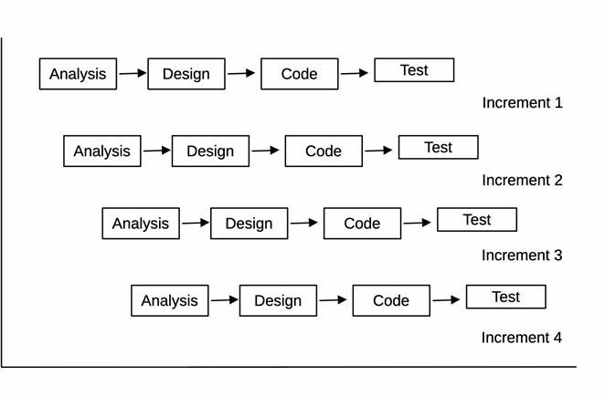

##### Figure 1: Incremental Model Methodology

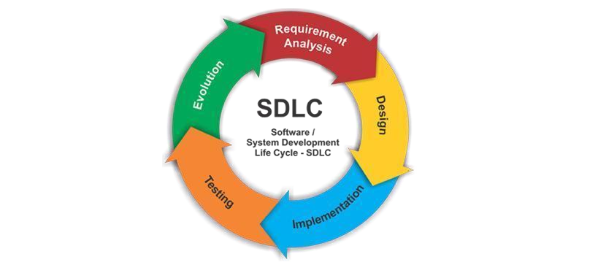

**Figure 2: Illustration of SDLC**

* + 1. REQUIREMENT ANALYSIS:

In this phase, analysis will be performed to find out the requirements of the system. The outcome of this phase would be a SRS which is an acronym for “system requirement specifications”

* + 1. DESIGN PHASE:

In this phase the SRS would be translated into the system design. Context diagram DFD ED diagram, use case diagram, sequence diagram and class diagram will be developed.

* + 1. CODING PHASE:

In this phase coding will be done according for the design and a working system will be developed by the end of the process.

* + 1. TESTING PHASE:

In this phase the system will be tested with each testing list of changes to the system developed, is suggested and the change will be applied to the software and the software would be delivered as a successive increment until a satisfying system is achieved.

#### SOFTWARE SPECIFICATION

1. **HTML:** Hypertext Markup Language is the standard markup language for documents designed to be displayed in a web browser. It can be assisted by technologies such as Cascading Style Sheets (CSS) and scripting languages such as JavaScript. Web browsers receive HTML

documents from a web server or from local storage and render the documents into multimedia web pages. HTML describes the structure of a web page semantically and originally included cues for the appearance of the document.

1. **CSS:** Cascading Style Sheets is a style sheet language used for describing the presentation of a document written in a markup language like HTML. CSS is a cornerstone technology of the World Wide Web, alongside HTML and JavaScript.CSS is designed to enable the separation of presentation and content, including layout, colors, and fonts. This separation can improve content accessibility, provide more flexibility and control in the specification of presentation characteristics, enable multiple web pages to share formatting by specifying the relevant CSS in a separate .css file, and reduce complexity and repetition in the structural content.
2. **PHP:** PHP is a recursive acronym for "PHP: Hypertext Pre-processor". PHP is a server side scripting language that is embedded in HTML. It is used to manage dynamic content, databases, session tracking, even build entire ecommerce sites. It is integrated with a number of popular databases, including MySQL, PostgreSQL, Oracle, Sybase, Informix, and Microsoft SQL Server PHP supports a large number of major protocols such as POP3, IMAP, and LDAP. PHP4 added support for Java and distributed object architectures (COM and CORBA), making n-tier development a possibility for the first time.
3. **PhpMyAdmin:** phpMyAdmin is a free and open-source administration tool for MySQL and Maria DB. As a portable web application written primarily in PHP, it has become one of the most popular MySQL administration tools, especially for web hosting services. Domains of phpMyAdmin:
   * Web interface
   * Import data from CSV, JSON and SQL
   * Network traffic to the SQL server
   * Administering multiple servers
4. **JavaScript:** JavaScript is a popular programming language used primarily for web development. It is a versatile, high-level, and interpreted language that allows developers to add interactive and dynamic elements to websites.

## PROPOSED SYSTEM

The proposed "Ecare" Hospital Management System is a comprehensive web-based application designed to streamline hospital operations, enhance patient care, and improve data security. The system will feature three primary modules tailored for administrators, doctors, and patients. The Administrator Module will provide tools for managing user accounts, doctor and staff profiles, patient records, appointment schedules, billing, and inventory. It will also generate detailed reports and analytics to support decision-making and ensure compliance with healthcare regulations. The Doctor Module will enable healthcare providers to access and update patient records, manage appointments, prescribe medications electronically, order and view lab results, and communicate securely with patients and other .The Patient Module will empower patients to manage their healthcare needs by allowing them to register, schedule appointments, access medical records, view prescriptions, make payments, and provide feedback. The system will be built on a robust and scalable platform, featuring a secure database and advanced security measures to protect sensitive data. It will offer an intuitive user interface to ensure ease of use for all users. By implementing the "Ecare" Hospital Management System, hospitals can significantly improve operational efficiency, data accuracy, patient engagement, and overall quality of care, while ensuring high standards of data security and regulatory compliance.

## USE CASE DIAGRAM

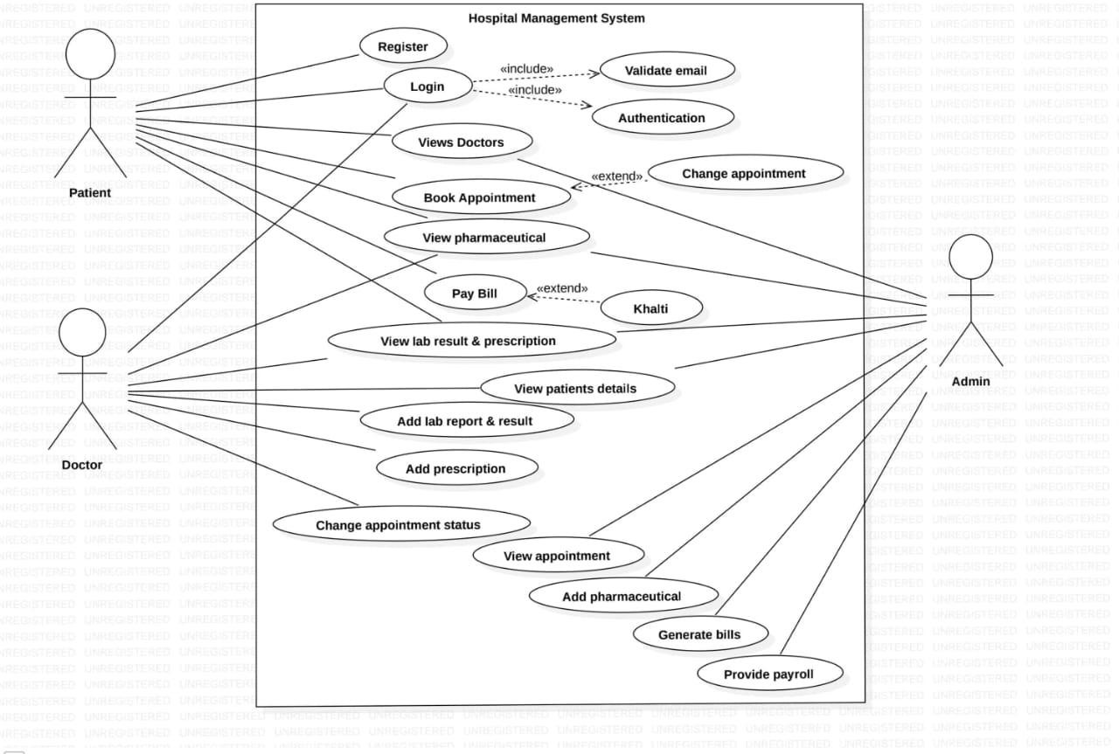

#### FIGURE 3:USE CASES DIAGRAM

## ER-DIAGRAM

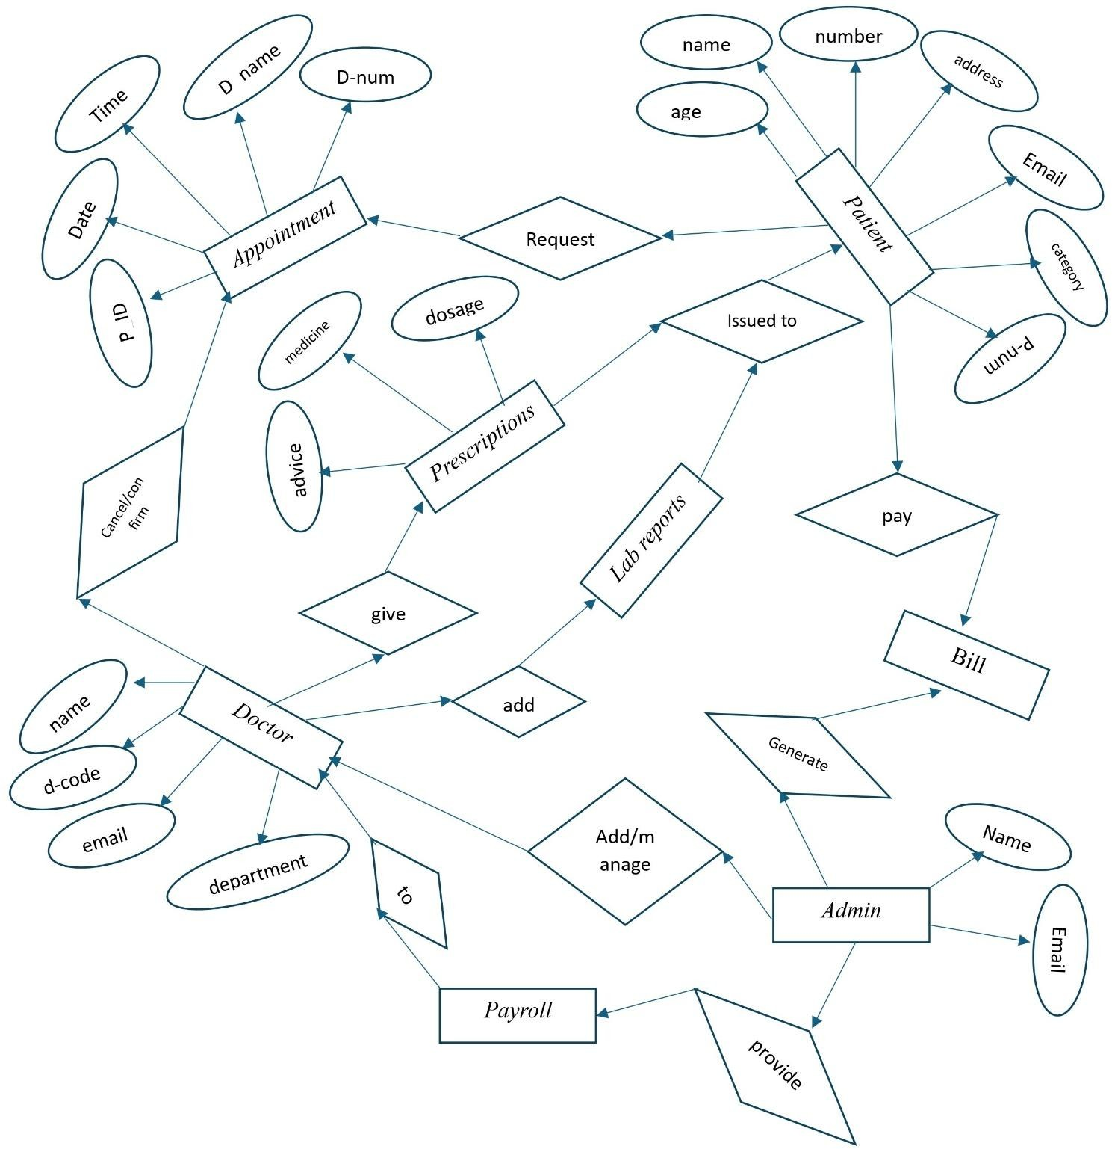

**FIGURE 4:ER DIAGRAM**

## SEQUENCE DIAGRAM

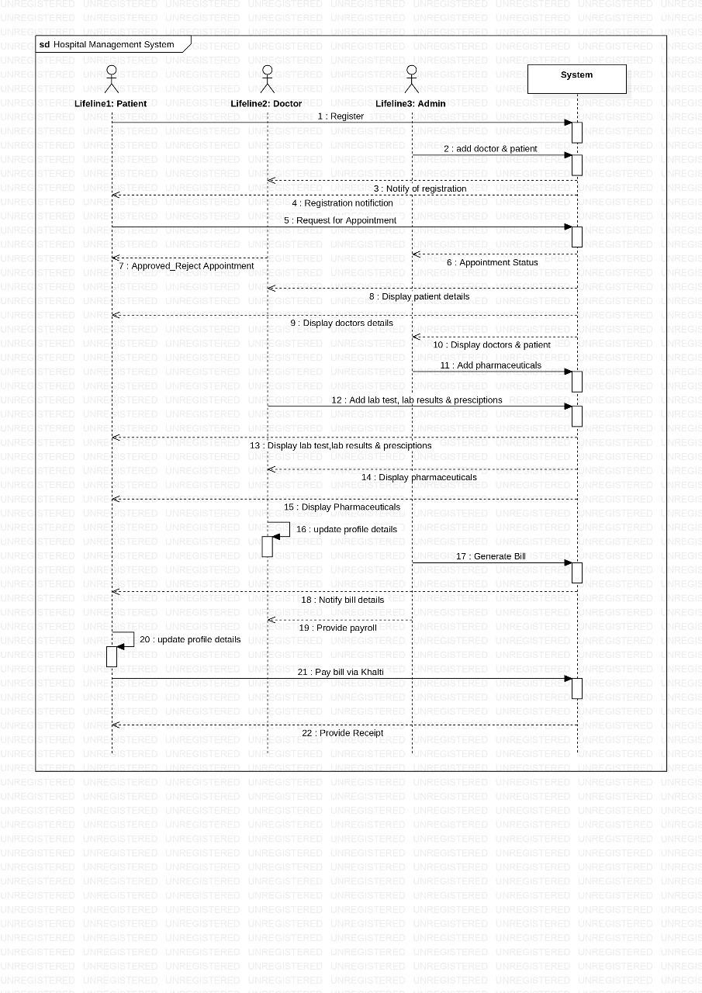**FIGURE 5: SEQUENCE DIAGRAM**

## CLASS DIAGRAM

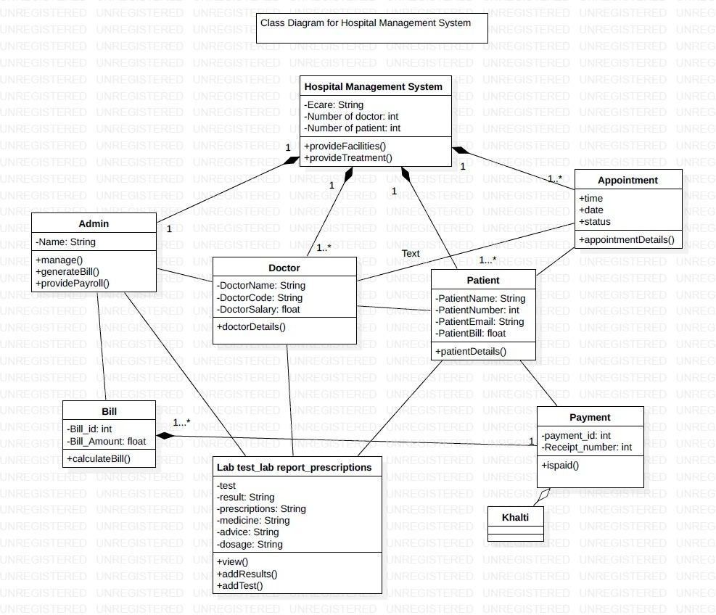

**FIGURE 6: CLASS DIAGRAM**

## PROJECT TASK & TIME SCHEDULE

|  |  |  |  |  |  |  |  |
| --- | --- | --- | --- | --- | --- | --- | --- |
|  | **July** | | | | | | |
| Weeks | 1st week | | 2nd week | | 3rd week | 4th week | |
| Requirement Gathering |  |  |  | |  |  | |
| Analysis |  |  |  | |  |  | |
| Design |  | |  |  |  |  | |
| Coding |  | |  |  | |  | |
| Testing |  | |  | |  |  |  |
| Implement |  | |  | |  |  |  |

|  |  |
| --- | --- |
| Name | Task Division |
| Pradeep Chaudhary | Backend, Frontend, Admin Panel |
| Prabin Yadav | Documentation, Frontend |
| Rahul Kumar Yadav | Documentation, Partial Coding |

### APPENDIX

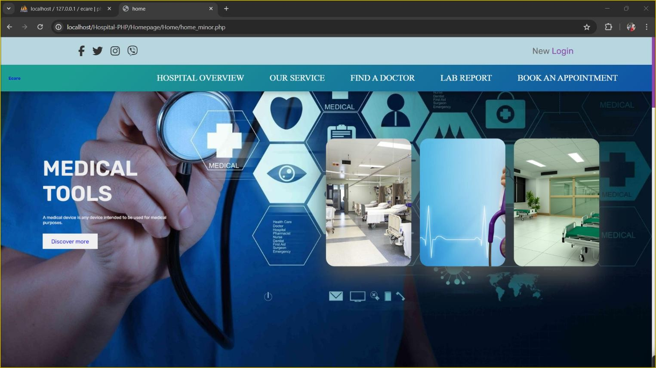

**Figure 7 :- Home Interface**

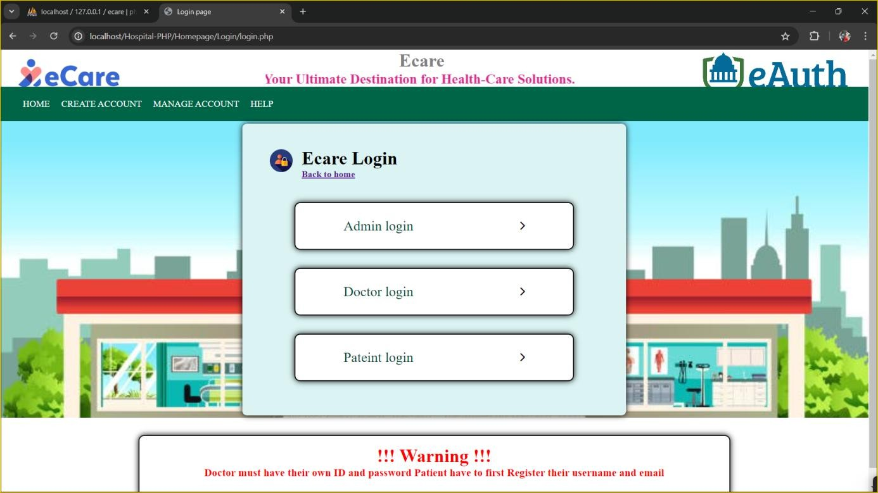

**Figure 8: - Login Module**

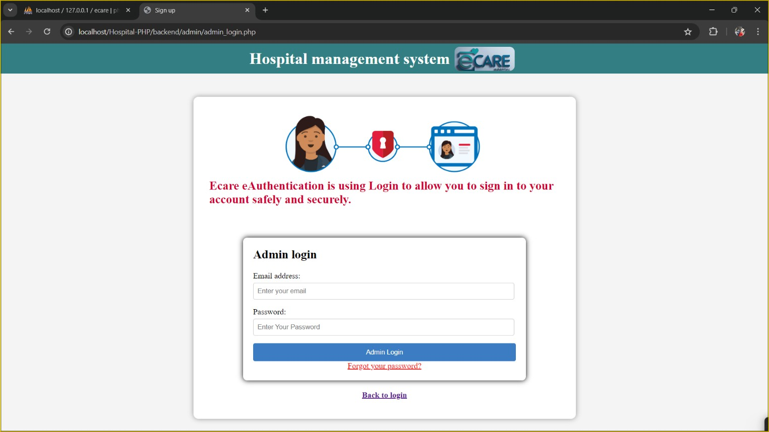

**Figure 9: - Login Form**

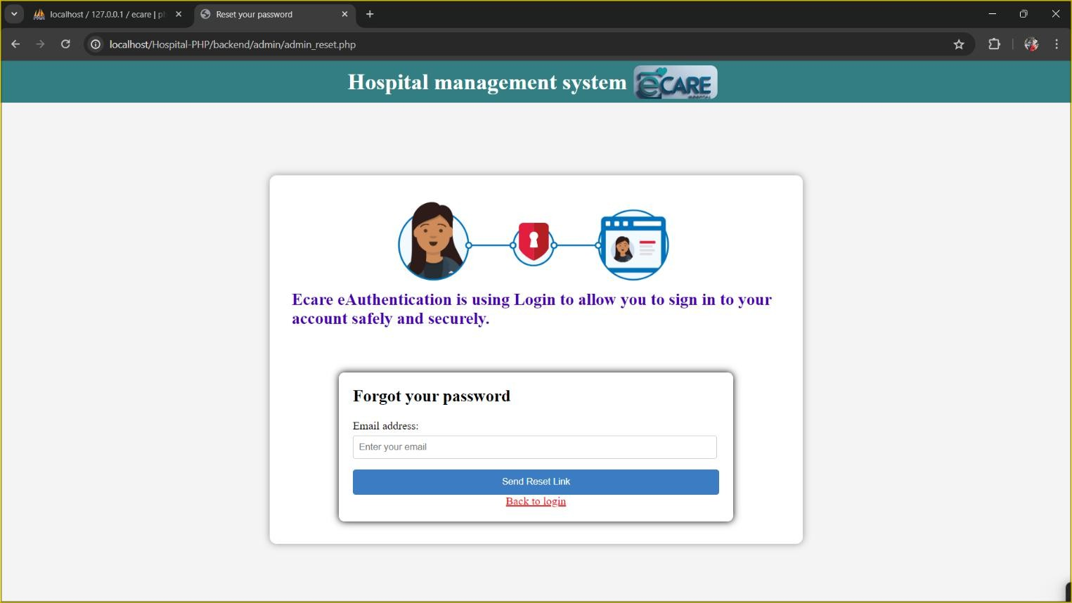

**Figure 10: -Reset Form**

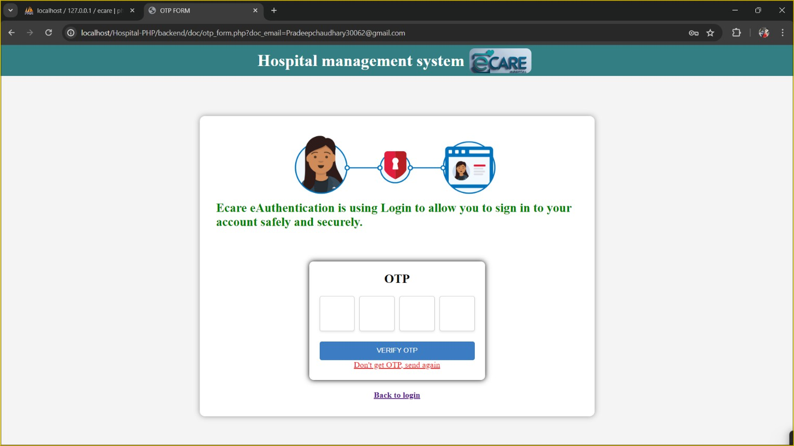

**Figure 11: -OTP form**

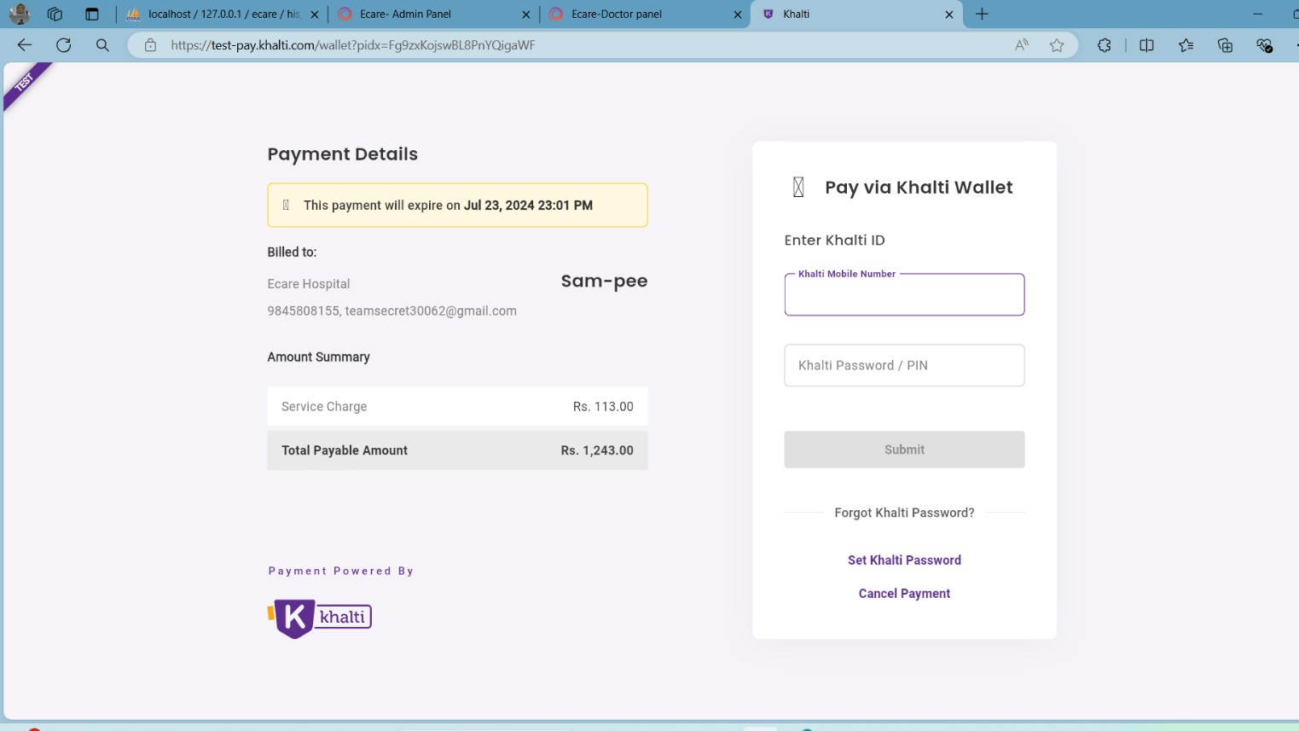

**Figure 12: -Payment Gateway**

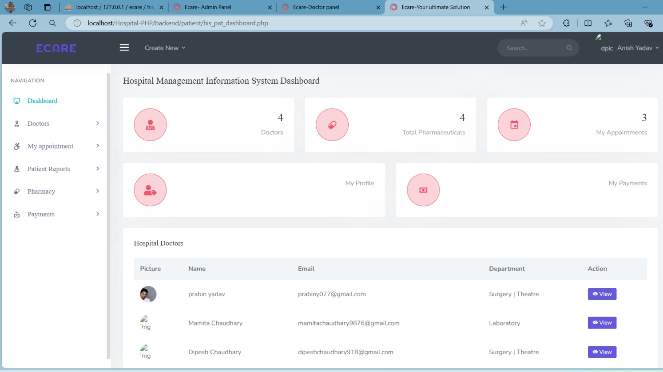

**Figure 13: -Patient Panel**

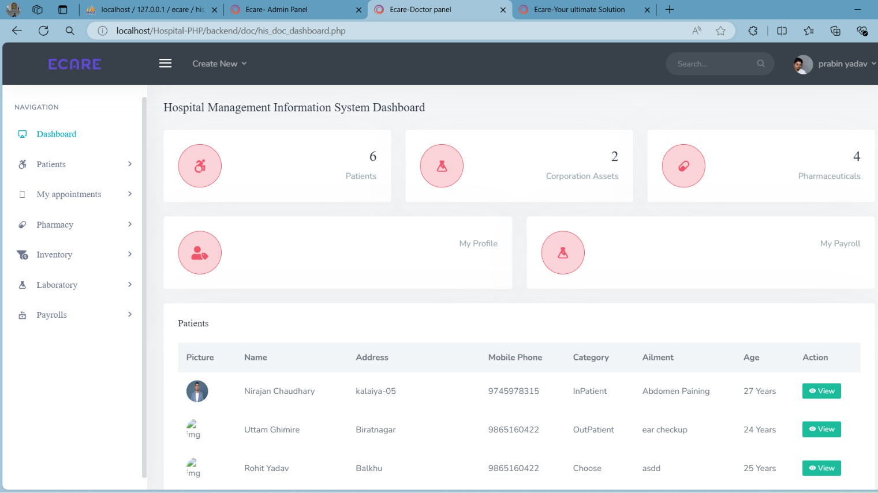

**Figure 14: -Doctor Panel**

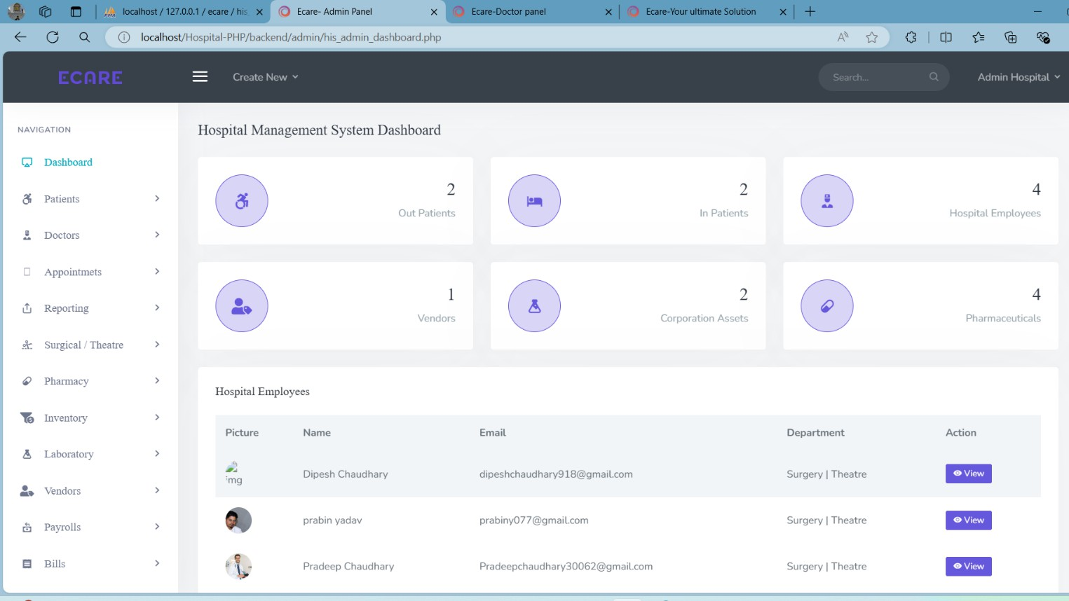

**Figure 15: -Admin Panel**

## REFERENCES

1. M. J. Ball and J. V. Douglas, "Hospital Information Systems: Design and Implementation,"Springer,1999.Available:<https://link.springer.com/book/10.1007/978-0-387-21919-9>. [Accessed: May 30, 2024].
2. R. T. Haux, "The Impact of Hospital Information Systems on Patient Care: A Review," International Journal of Medical Informatics, vol. 73, no. 3, pp. 71-81, 2004. Available: <https://www.sciencedirect.com/science/article/abs/pii/S1386505603001889>. [Accessed: June 24, 2024].
3. K. A. Wager, F. W. Lee, and J. P. Glaser, "Healthcare Information Systems: A Practical Approach for Health Care Management," 4th ed., Jossey-Bass, 2017. Available: <https://www.wiley.com/en-us/Healthcare+Information+Systems%3A+A+Practical+Approach+for+Health+Care+Management%2C+4th+Edition-p-9781119337188>. [Accessed: July 15, 2024].
4. Health Level Seven International, "FHIR: An Overview of Fast Healthcare Interoperability Resources," HL7, 2019. Available: https://www.hl7.org/fhir/overview.html. [Accessed: July 30, 2024].